Mini light weight golf stand bag
1.Lightweight design at only 4.5 lbs;
2.heavy duty nylon construction ensures long lasting durability
3.club dividers keep clubs separated and secured; easy open/close magnetic ball pocket
4.Adjustable dual strap delivers the perfect fit for maximum carrying ease and comfort
5.Velour lined water-resistant valuables pocket
6.metal towel loop; Velcro glove holder; insulated cooler pocket
7.FREE PERSONALIZATION (ball pocket)

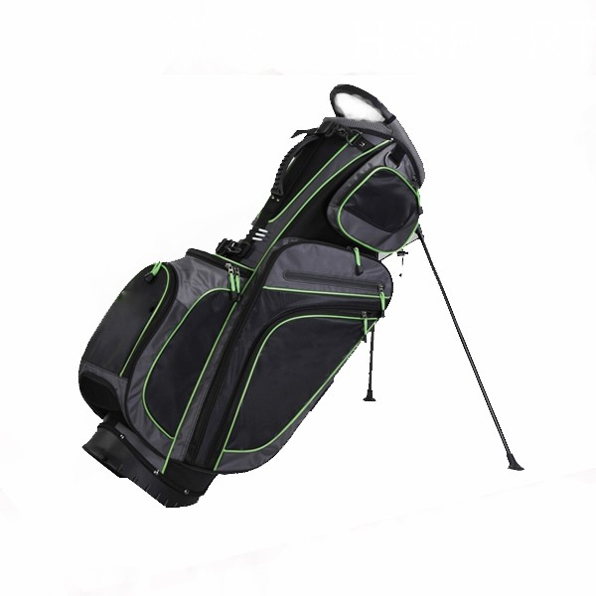
More information please click here: www.tt-golf.com

